Microsoft Azure Administration LAB Manual (AZ-104)

--Vijaya Kumar Vemula

Table of Contents

1) Azure Resource Groups 3

1. Lab Overview 3

2. Creation of Azure Resource Groups 3

3. Settings of Azure Resource Groups 6

4. Creation of Resources in Resource Groups 6

5. Moving Resources between Resource Groups. 6

6. Deletion of Resource Groups 6

# Azure Resource Groups

## Lab Overview

In this lab you will get hands-on experience with Resource Groups and their features. In this module we will create two Resource Groups **RG1** (using portal) and **RG2** (Using PowerShell/Azure CLI)in the location **Central US**, understand settings of a Resource Group, create resources in Resource Group **RG1,** move resources from Resource Group **RG1** to **RG2.** Finally, Deletion of Resource Group.

## Creation of Azure Resource Groups

1. Creation of Resource Group RG1 using Azure portal
2. Login to Azure portal <https://portal.azure.com>
3. Type Resource Groups in the search bar and select it, or select it from **Favorites** as highlighted below.

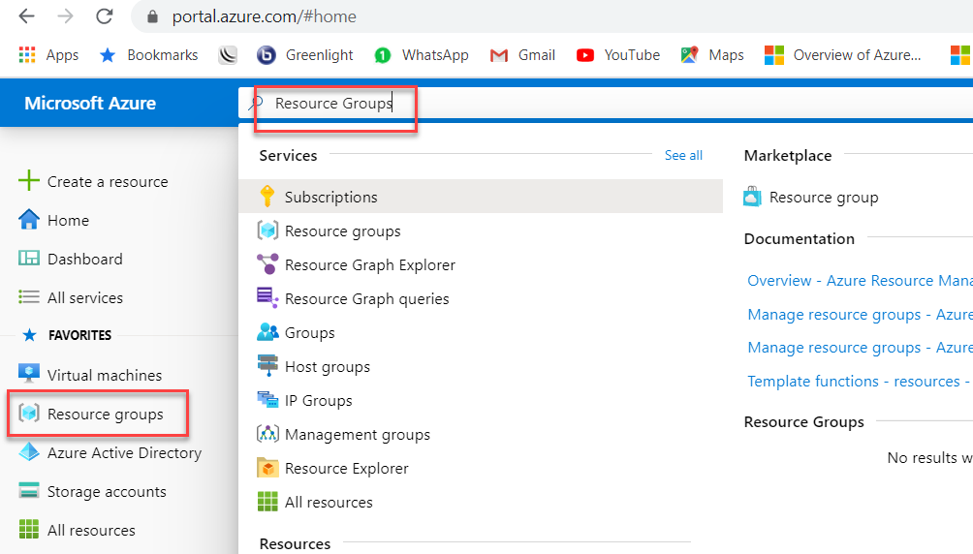

1. Select Add as highlighted below to create Resource Group.

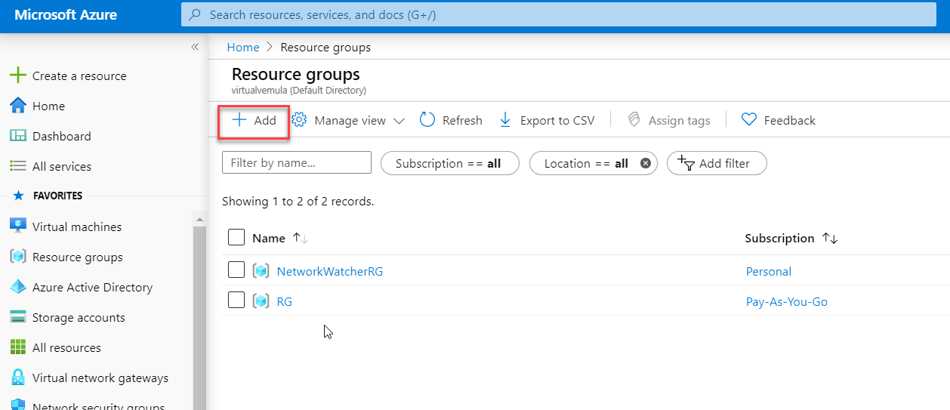

1. Select the Subscription, In the below image there are two subscriptions.

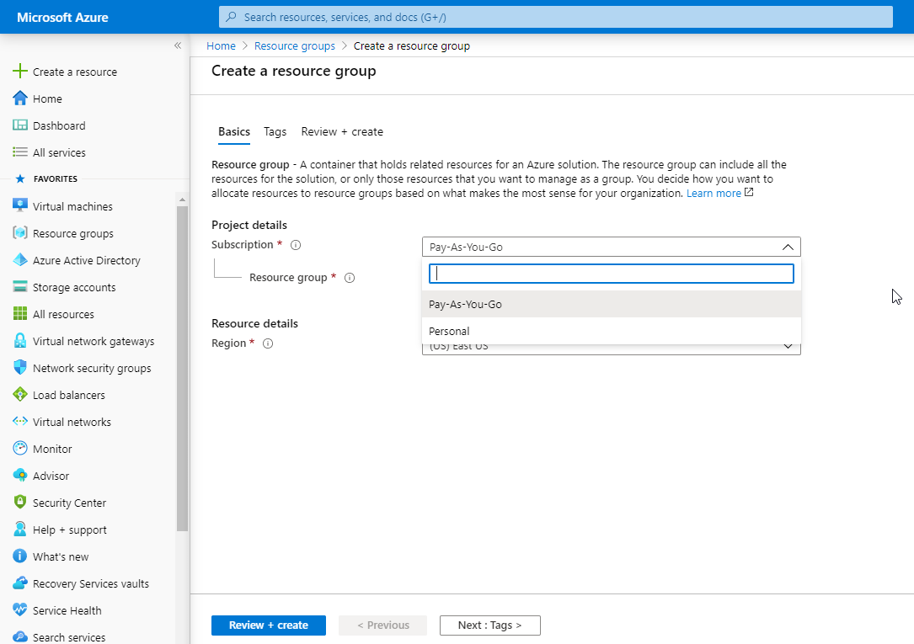

1. Our requirement is to create Resource Group RG1 provide Resource group name as RG1 and Region/Location as Central US highlighted below.

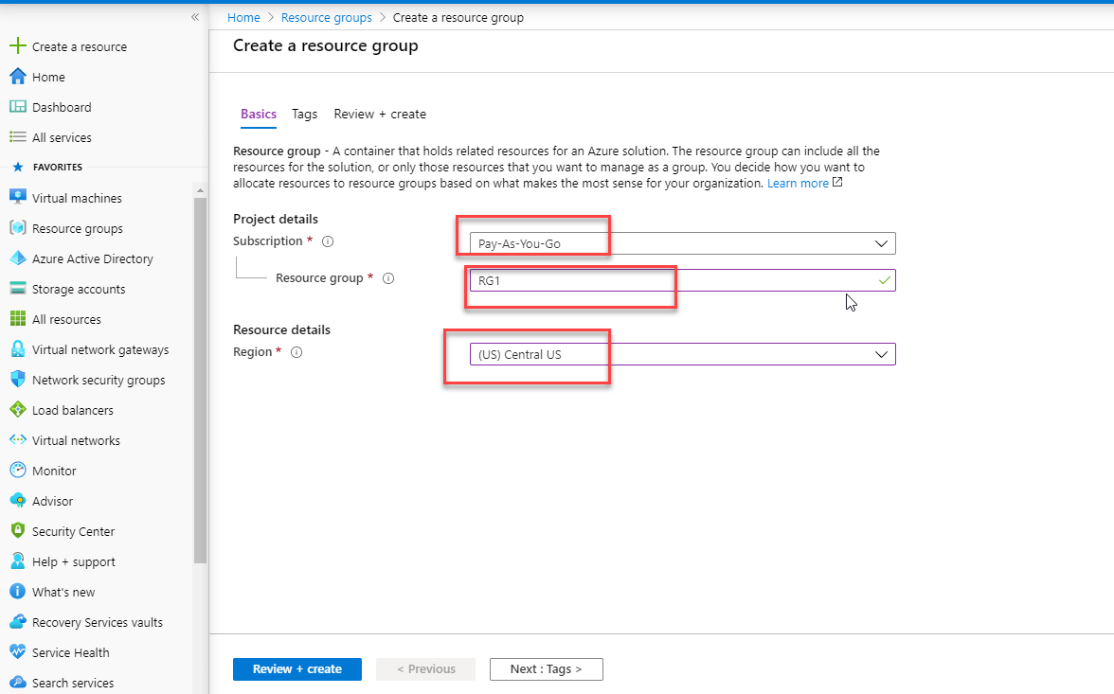

1. We are not going to use Tags now hence click Review + create for successful validation. Click on Create for the creation of Resource Group RG1.

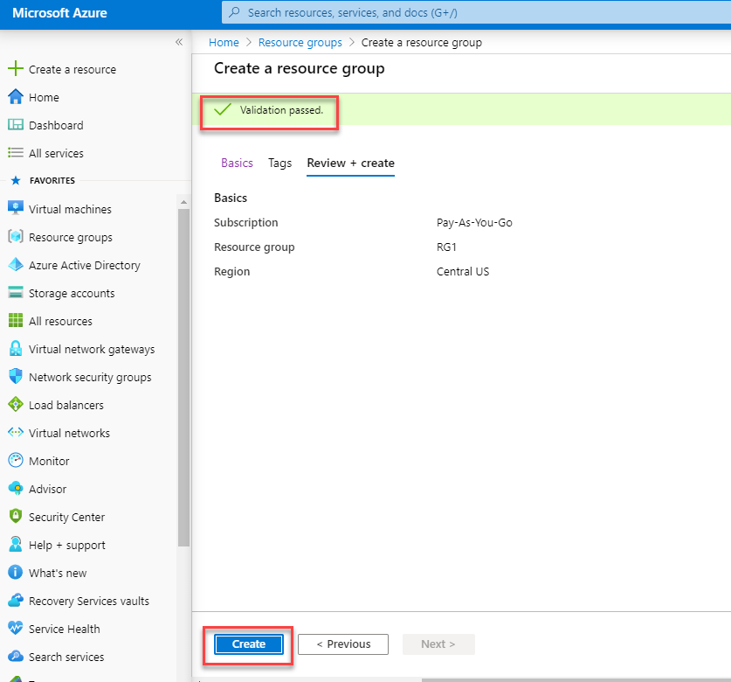

1. Deployment status of Resource Group RG1 is shown in the notification area (bell icon), which shows deployment as successful.

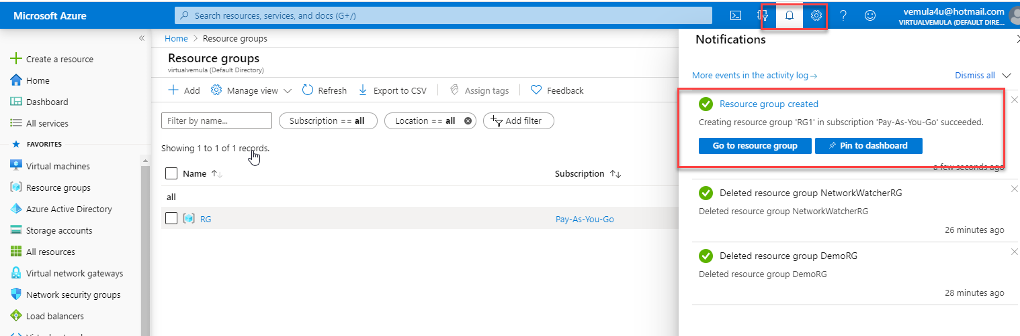

1. Navigate back to Resource Groups either using Search bar or using resource groups option in the favorites as shown in point 2 above. Check the RG1 is available as highlighted below.

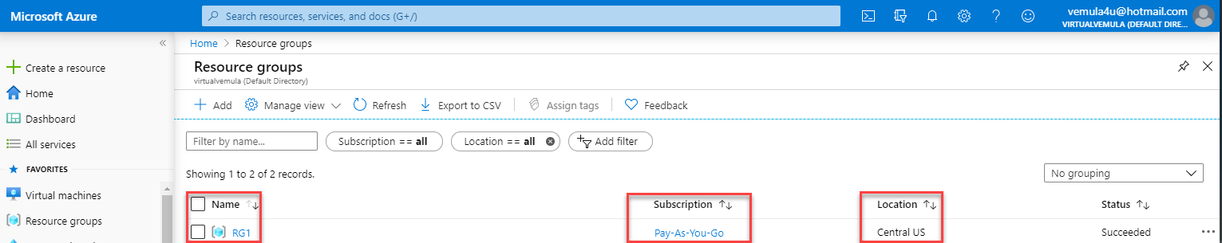

1. Creation of **Resource Group** RG2 using Azure **PowerShell** and **Azure CLI.**

Before using PowerShell to deploy and manage resources in azure, installing PowerShell modules on your windows machine is must. Other Azure PowerShell commands are not recognized. Refer my article here [How-to Setup Azure PowerShell](https://www.virtualvemula.com/2019/05/setting-up-azure-powershell.html). Alternatively, **Azure shell** which is part of Azure portal can also be used.

Once PowerShell modules for Azure are installed launch PowerShell with **Run as Administrator** and follow below commands

1. Connect to Azure Environment run the below command in PowerShell you will prompted to enter your azure credentials.

PS C:\> Connect-AzAccount

1. Connect to Azure Environment run the below command in PowerShell you will prompted to enter your azure credentials.

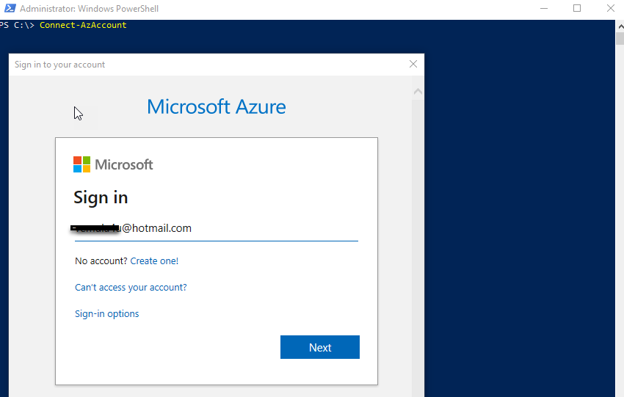

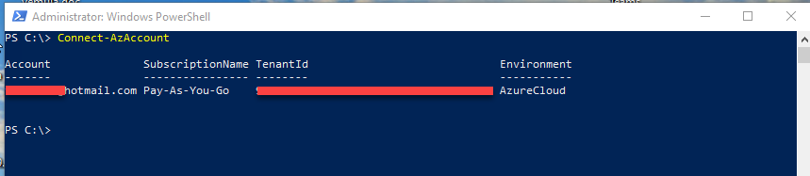

1. Use below command to get current Resource Groups. RG1 which we created using portal will be listed.

PS C:\> Get-AzResourceGroup

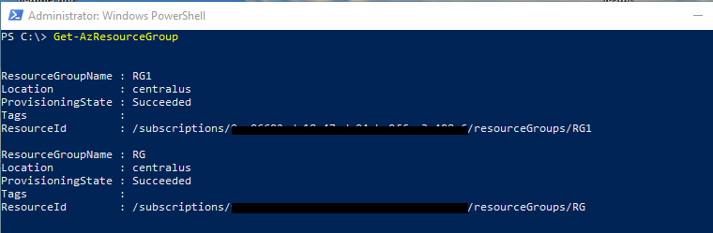

1. Use below command to create our second Resource Group **RG2.**

PS C:\> New-AzResourceGroup -Name RG2 -Location “Central US”

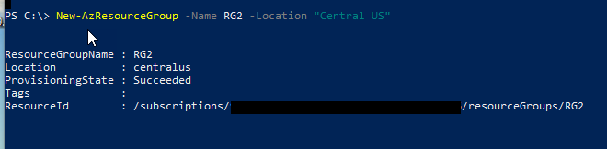

1. Check both Resource Groups **RG1** and **RG2** are visible usingbelow command.

PS C:\> Get-AzResourceGroup.

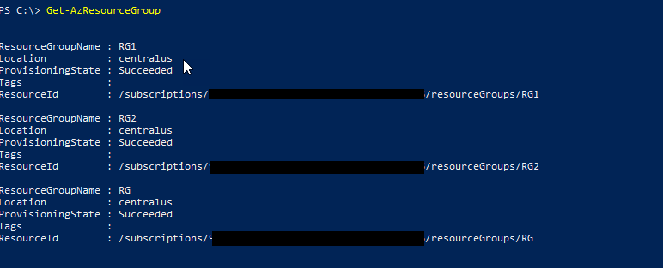

Let us check how can we use **Azure CLI** for creating **Resource Groups.** Before using AZ CLI install Azure CLI following the instructions here [Azure CLI installation on Windows Machine.](https://docs.microsoft.com/en-us/cli/azure/install-azure-cli-windows?view=azure-cli-latest)

Once Azure is installed launch Commandshell or PowerShell with **Run as Administrator** and follow below commands

1. Connect to Azure Environment run the below command in cmd shell you will prompted to enter your azure credentials.

C:\>az login

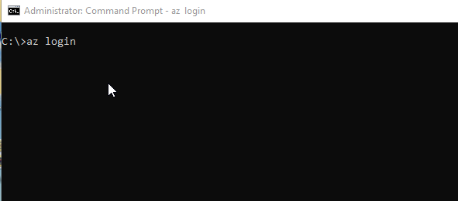

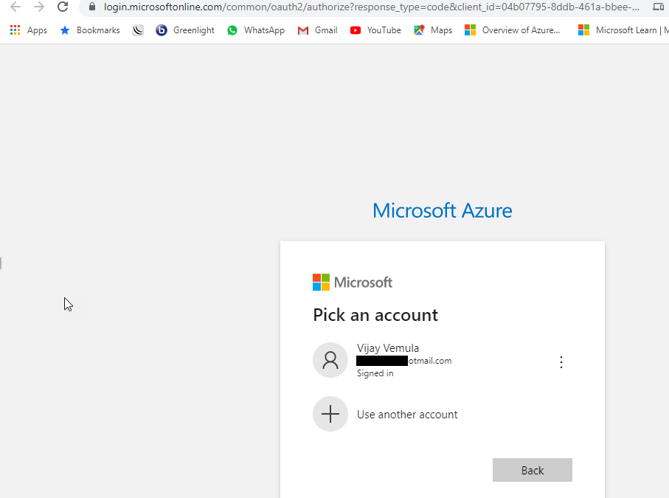

1. Use below command to get current Resource Groups. RG1,RG2 which we created using portal and PowerShell will be listed.

C:\>az group list

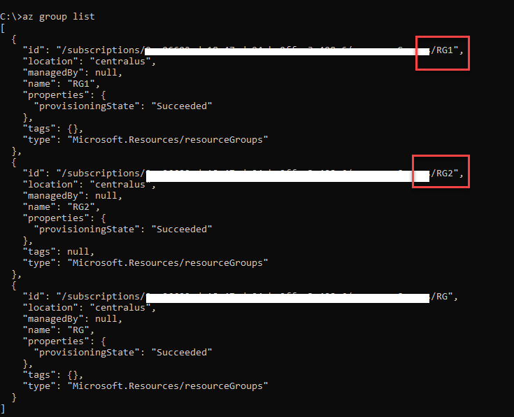

1. Use below command to create our third Resource Group RG3 using Azure CLI.

C:\>az group create --name RG3 --location "Central US"

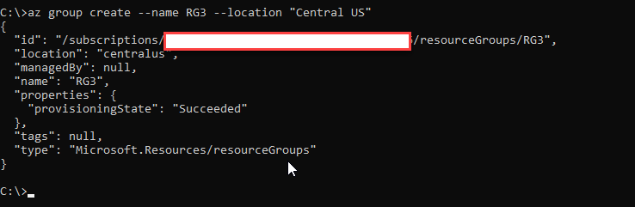

1. Check if Resource Groups **RG1, RG2** and RG3 are visible usingbelow command.

C:\>az group list

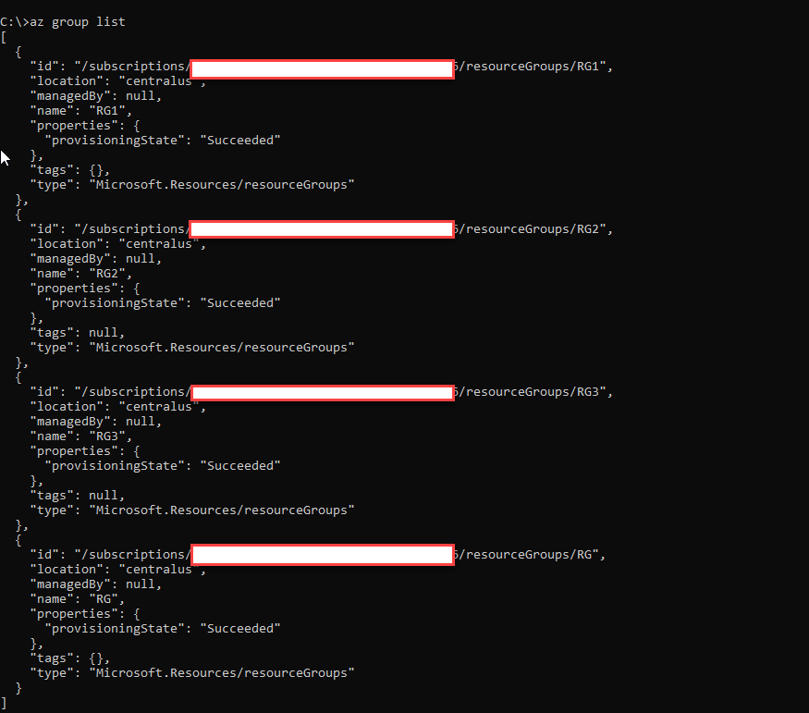

This marks the end of creation of 3 Resource Groups RG1, RG2, RG3 using Portal, PowerShell and Azure CL

## Creation of Resources in Resource Groups.

In this section let us create a Windows Virtual Machine in the Resource Group RG1 using PowerShell, detailed explanation of creation of Virtual Machine will be covered in a sperate document.

1. Log into Azure using PowerShell command as shown below.

PS C:\> Connect-AzAccount

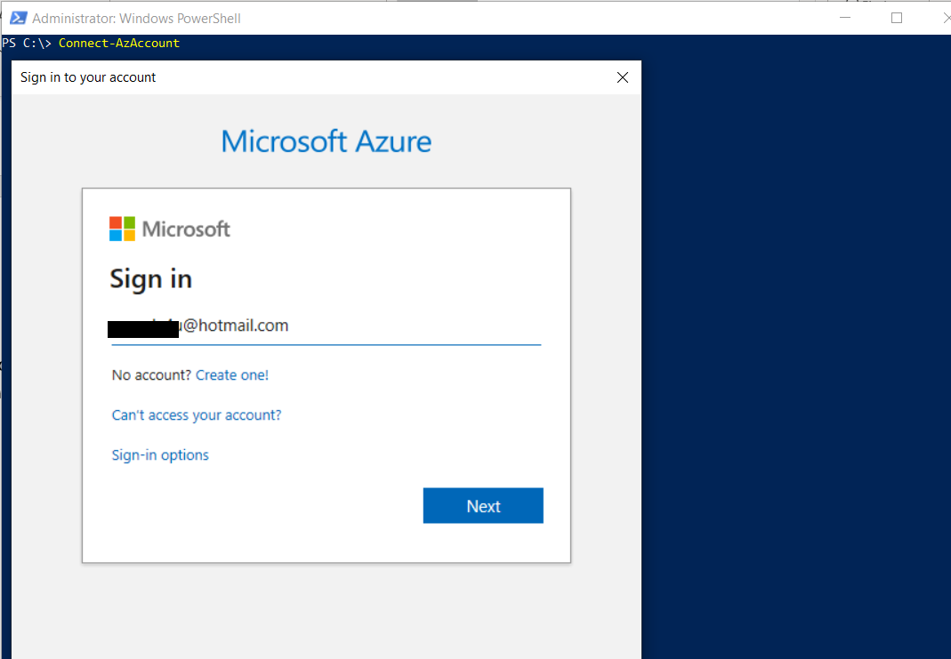

1. Use the following command to create a Virtual Machine with default values (We will discuss VM creation separately)

PS C:\> New-AzVM -ResourceGroupName RG1 -Name VM-1 -Location "Central US"

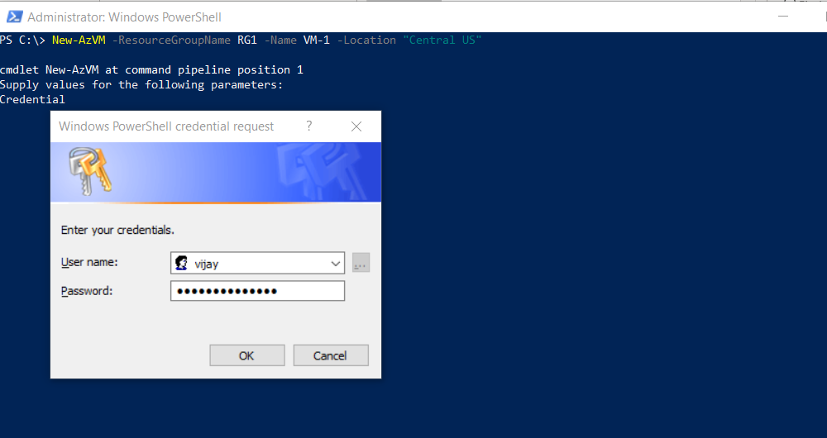

1. Once we have **VM-1** created in Resource Group **RG1** are you see below output

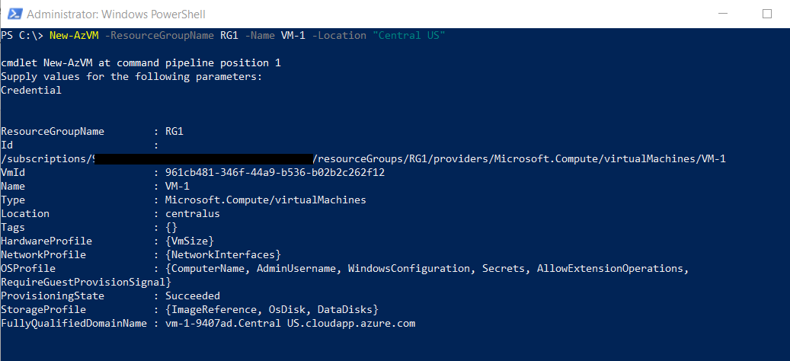

1. Login to Azure portal and navigate to Azure Resource Group RG1 then you'll see resources relating to VM-1 which we created above. When we deploy virtual machine there are related/associated resources of VM1 will get created ex: Network Interface Card, Public IP Address Disks etc as shown in the below screenshot.

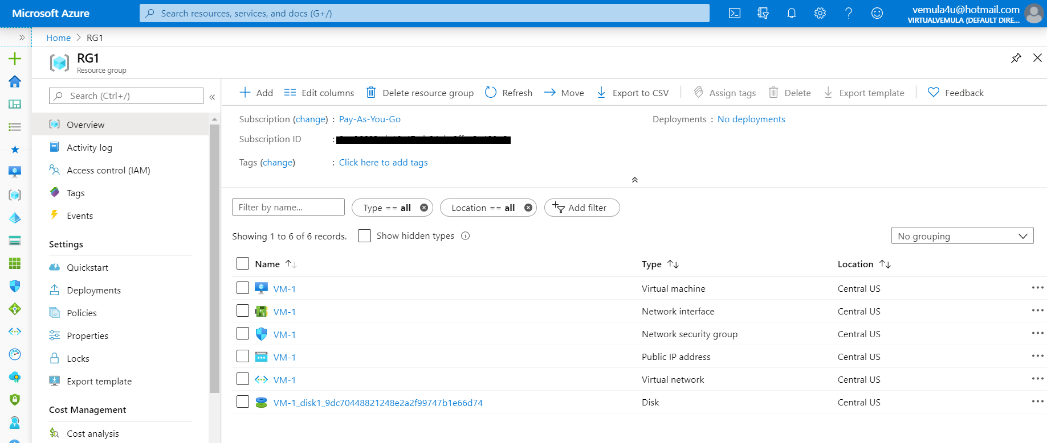

In the above scenario we have Virtual Machine resources in the resource group RG1, we will move these resources to resource group RG2 in the next section.

## Moving Resources between Resource Groups.

In this section we will understand how to move resources between 2 resource groups in our case RG1 and RG2.

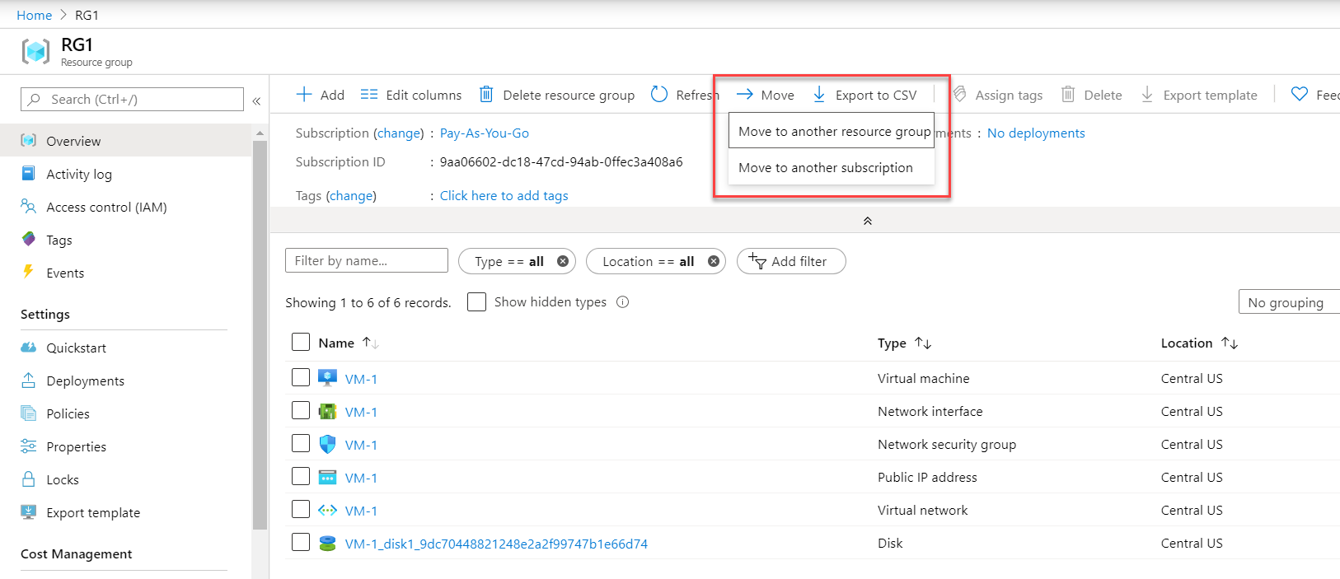

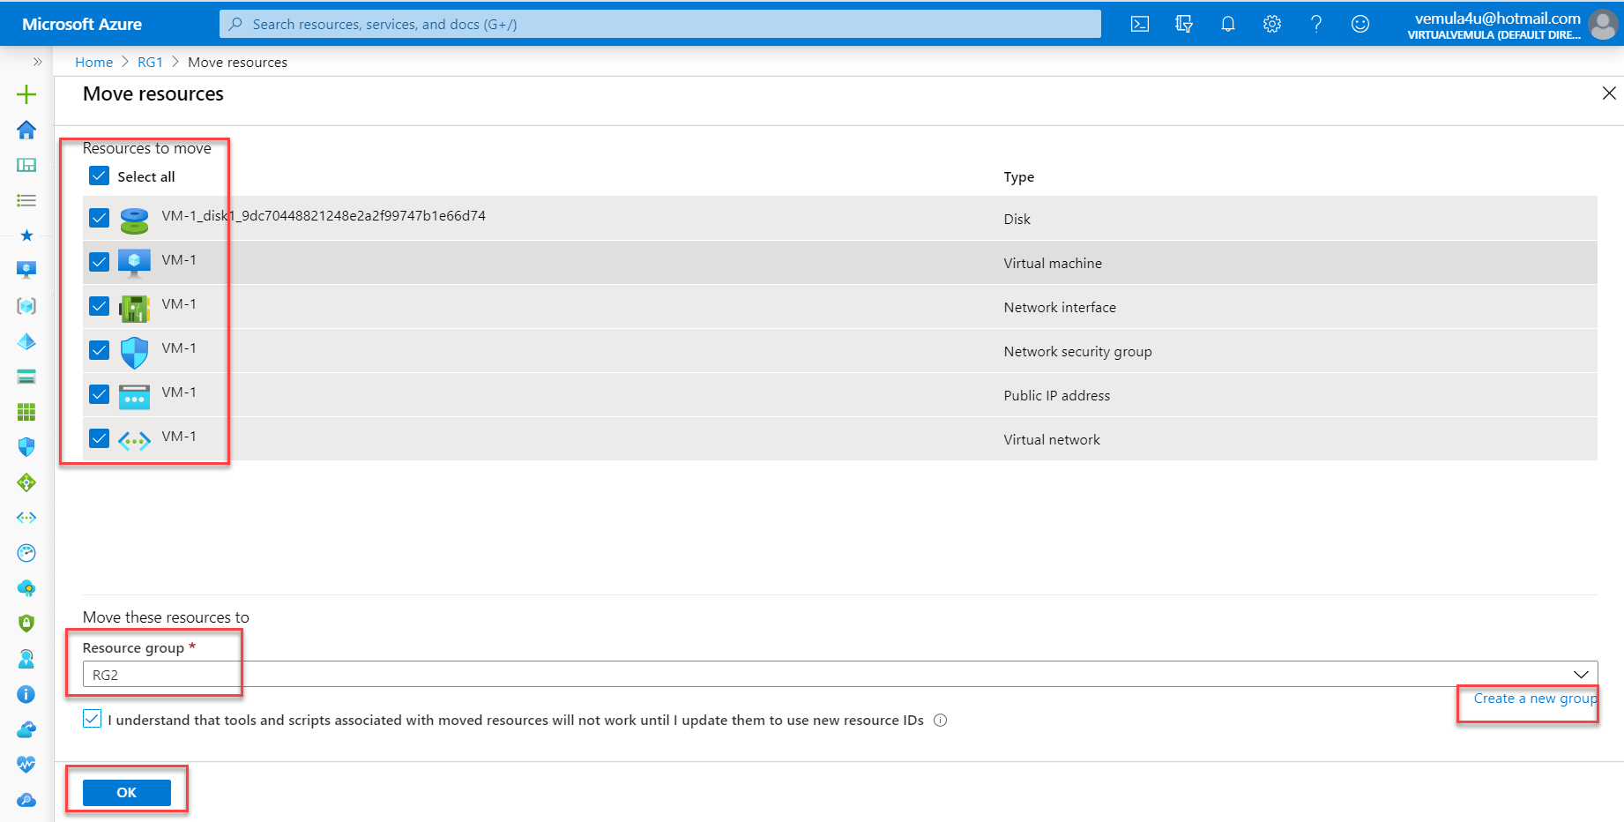

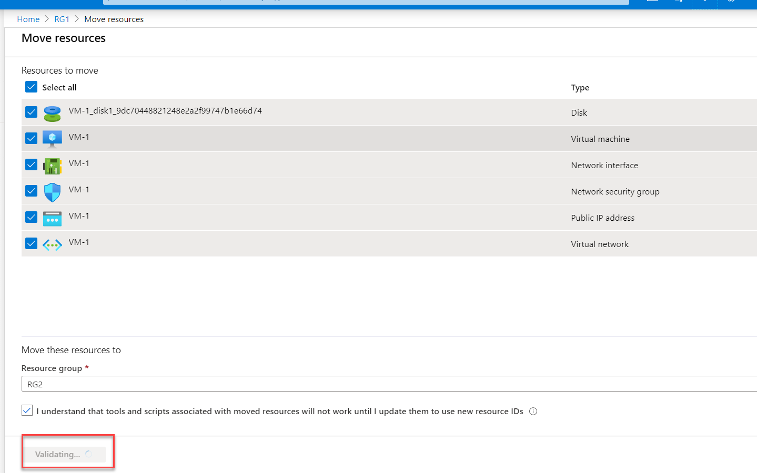

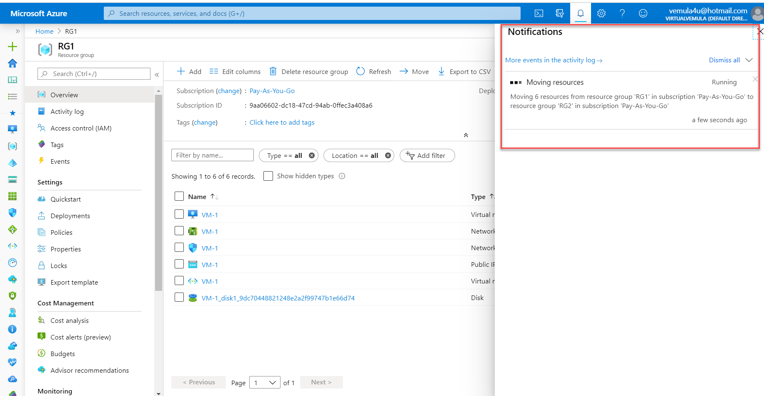

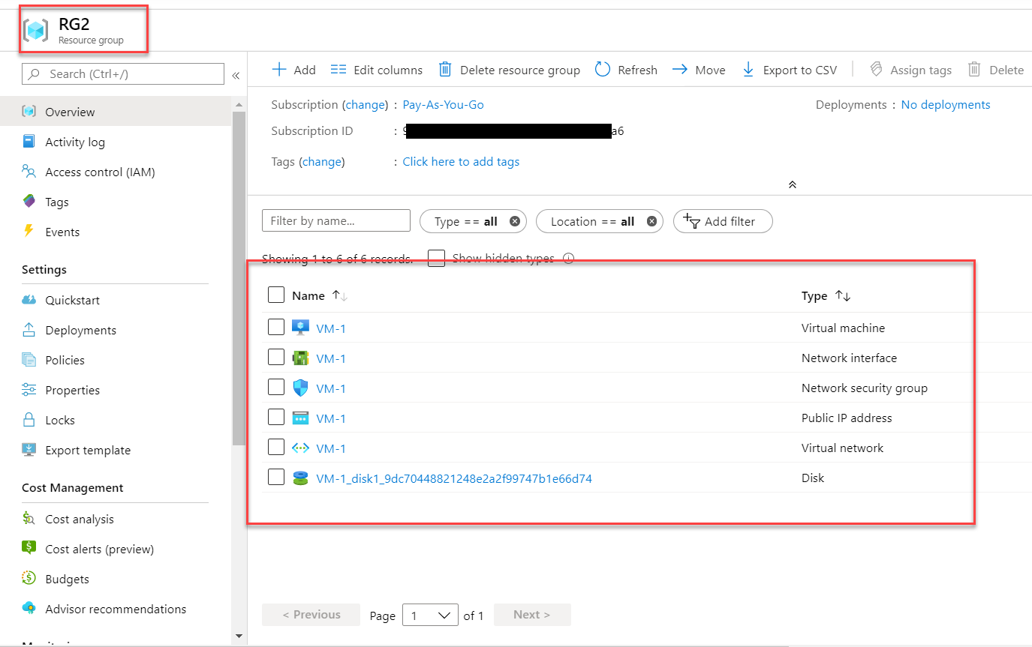

## Deletion of Resource Groups